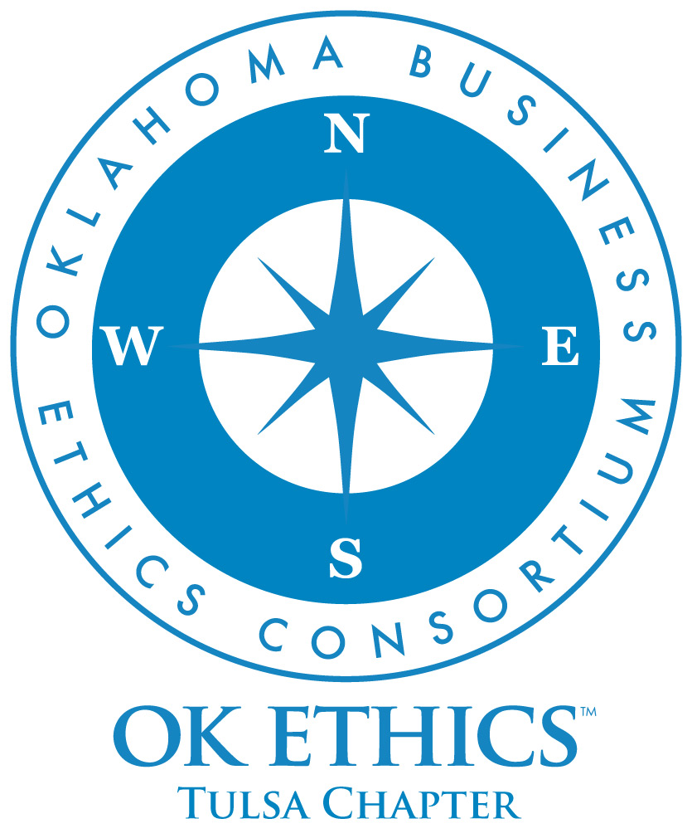
OKLAHOMA BUSINESS
ETHICS CONSORTIUM
Tulsa Chapter Meeting
February 26th, 2009

Meeting Agenda

I. Welcome (11:45) Nick Minden, Chapter President

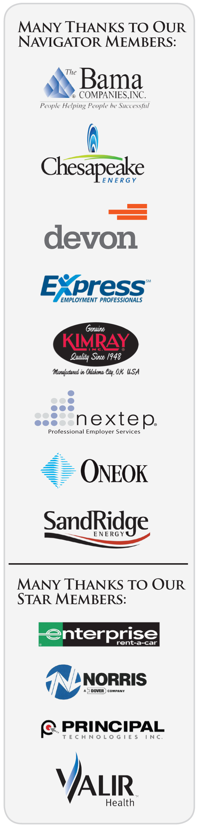
Special thanks to our many volunteers and Legacy team members for making this meeting possible: Carol Swarthout, Lynn Flinn, John Stancavage, Micheal Oonk, Whitney Mathews, Jan Laub, Jenny Lizama, Jennifer Lyon, Tom Clatfelter, David
White, Shere Rockwell, Kevin Kennemer, Jana Momeni, Kari Culp, Royce Kelly.

II. Announcements Nick Minden
a. Student Ethics Challenge
b. OKEthics Scholarships

III. Guiding Principle (11:50) Nick Minden
& Member Awards Whitney Matthews, Membership
Michael Oonk, Membership

IV. Introduction of Speaker (12:00) Lynn Flinn, Tulsa Legacy Team

V. Speaker Robyn Ewing, Sr. Vice-President
The Williams Companies

"Core Values & Corporate Responsibility:
100 Years of History”
About our speaker: Robyn Ewing was named senior vice president of strategic services and administration and chief administrative officer in 2008. She served as vice president of human resources from 2004-08. Prior to joining Williams, Ewing worked at MAPCO (merged with Williams in April 1998) and Cities Service Company. Ewing earned her undergraduate degree from the University of Tulsa and completed the executive programs at the Center for Creative Leadership and Wharton Business School. Ms. Ewing serves in a leadership role in numerous professional and charitable organizations.

VI. Q&A (12:45)

VI. Closing remarks (1:00) Nick Minden

General Disclaimer: Members of the Oklahoma Business Ethics Consortium frequently share information concerning various issues and developments that may have legal implications. The discussions, commentary, and handouts at Consortium meetings or presentations to other organizations are for general informational purposes only. They cover only some aspects of the subject topic, and do not constitute a complete legal analysis of the topic or how it might apply to any particular set of facts. Before taking any action based on information presented during a Consortium event, participants are encouraged to consult a qualified attorney.
The observations and comments of presenters at Consortium meetings and networking are the views and opinions of the presenter and do not constitute the opinion or policies of the Consortium or any of its members. Presenters are respectfully requested to avoid profanity, preaching, politics and self-promotion during their lectures.

OK ETHICS – Upcoming Events

Tulsa Chapter
- March 26 Panel Discussion – Generations in the Workplace

OKC Chapter
- March 11 Clifton Taulbert, The Building Community Institute - "Inside Community."
- April 29 OKEthics Annual Compass Awards, Speaker Sherri Coale, University of Oklahoma

To register for a Tulsa event, or see a list of Oklahoma City or Norman chapter meetings, go to our Web site at www.okethics.org or call 918-808-1086

Important information about CPE Credits
Recommended for 1 CPE for CPA’s: It is the responsibility of participants to demonstrate applicability of each program for demonstration of earned CPE credits, to his/her area of practice. OK Ethics makes no guarantees. Also, attendees must be present to accept CPE certificate at the conclusion of the program. These cannot be emailed.
OK ETHICS - Membership

Join today – You can make a difference!

Corporate Levels
NAVIGATOR $7,500 Includes 16 memberships; prepaid for all
OkEthics events – including Compass Awards
STAR $5,000 Includes 8 memberships; prepaid for all OkEthics
events – including annual Compass Awards
HORIZON $3,000 Includes 8 prepaid meals at all Tulsa events
LEADING $1,250 Includes 2 prepaid meals at all Tulsa events
FRONTIER $350 Includes 8 memberships; 8 members may attend
events at the discounted member rate

Individual Levels
TRAILBLAZER $500 Includes 1 prepaid meal at all Tulsa events
SCOUT $75 No prepaid meals; may attend events at
the discounted member rate

For more information on membership, go to www.okethics.org

PLEASE HELP US CONTROL COSTS BY LEAVING YOUR NAME TAG HERE!

